Part-1

11x11 12x12 13x13

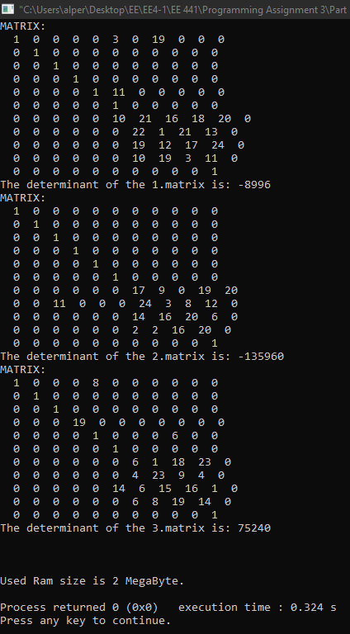 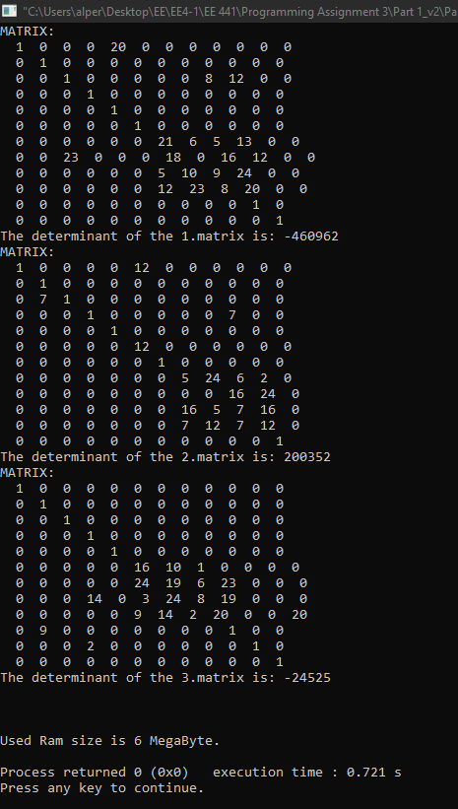

14x14 15x15

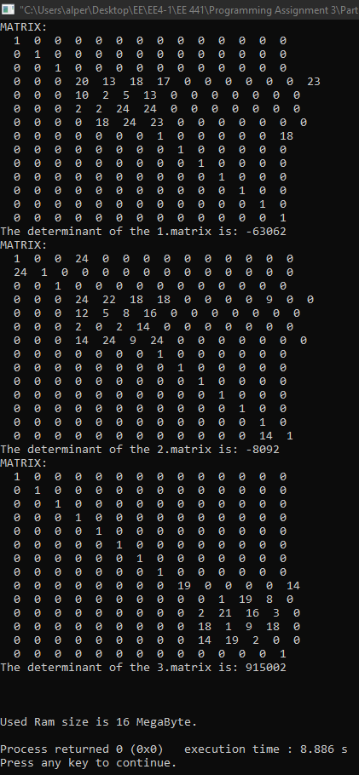

Part-2

11x11 12x12 13x13

14x14 15x15

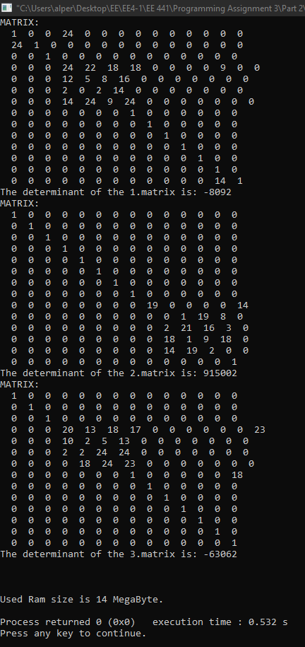

Part-3

In part 1, while ram usage increases linearly, we cannot say the same thing for execution time. After N=12, since reaching the nodes of the tree is getting harder, execution time becomes increasing logarithmically.

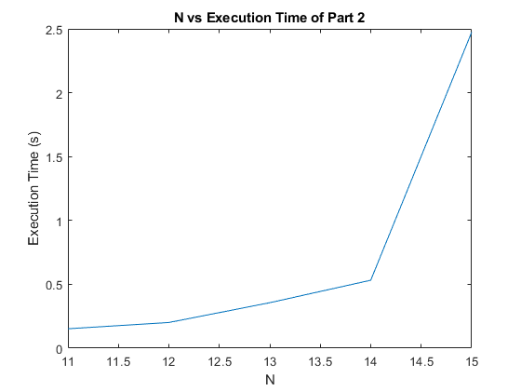

In part 2, while ram usage increases linearly, we cannot say the same thing for execution time in this part too. After N=14, since Hash Table is wholly filled, more members cannot be added, so the execution time increases logarithmically.